**AMRAPALI CLOUD VILLE FLOOR PLAN**

[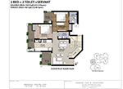](http://www.amrapaligroups.co.in/images/cloud-ville-floor1.jpg)

[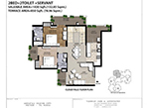](http://www.amrapaligroups.co.in/images/cloud-ville-floor2.jpg)

[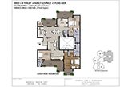](http://www.amrapaligroups.co.in/images/cloud-ville-floor3.jpg)

[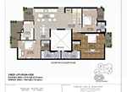](http://www.amrapaligroups.co.in/images/cloud-ville-floor4.jpg)

[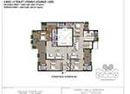](http://www.amrapaligroups.co.in/images/cloud-ville-floor5.jpg)

[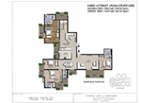](http://www.amrapaligroups.co.in/images/cloud-ville-floor6.jpg)

[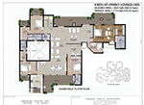](http://www.amrapaligroups.co.in/images/cloud-ville-floor7.jpg)

[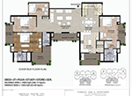](http://www.amrapaligroups.co.in/images/cloud-ville-floor8.jpg)

[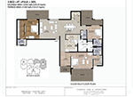](http://www.amrapaligroups.co.in/images/cloud-ville-floor9.jpg)

[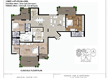](http://www.amrapaligroups.co.in/images/cloud-ville-floor10.jpg)

[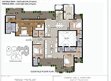](http://www.amrapaligroups.co.in/images/cloud-ville-floor11.jpg)

[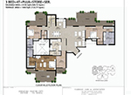](http://www.amrapaligroups.co.in/images/cloud-ville-floor12.jpg)

[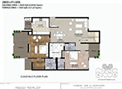](http://www.amrapaligroups.co.in/images/cloud-ville-floor13.jpg)

[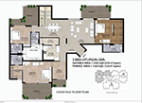](http://www.amrapaligroups.co.in/images/cloud-ville-floor14.jpg)

**AMRAPALI CLOUD VILLE MASTER PLAN**

[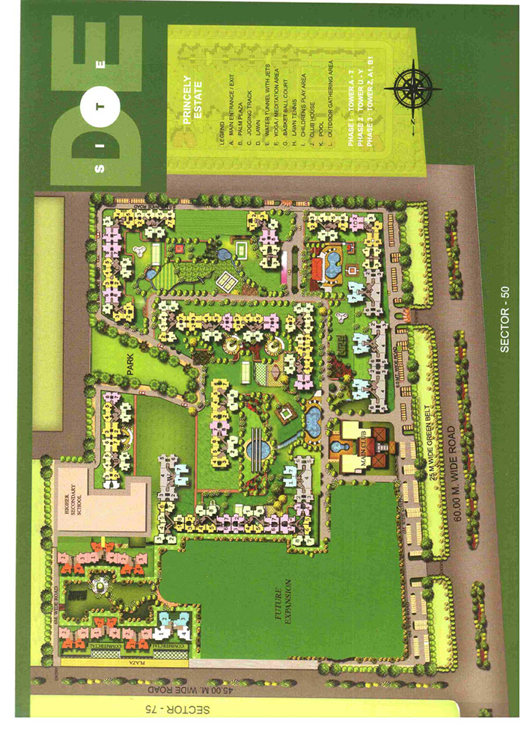](http://www.amrapaligroups.co.in/images/amrapali-cloudville-sitemap.jpg)

**AMRAPALI CLOUD VILLE LOCATION MAP**

[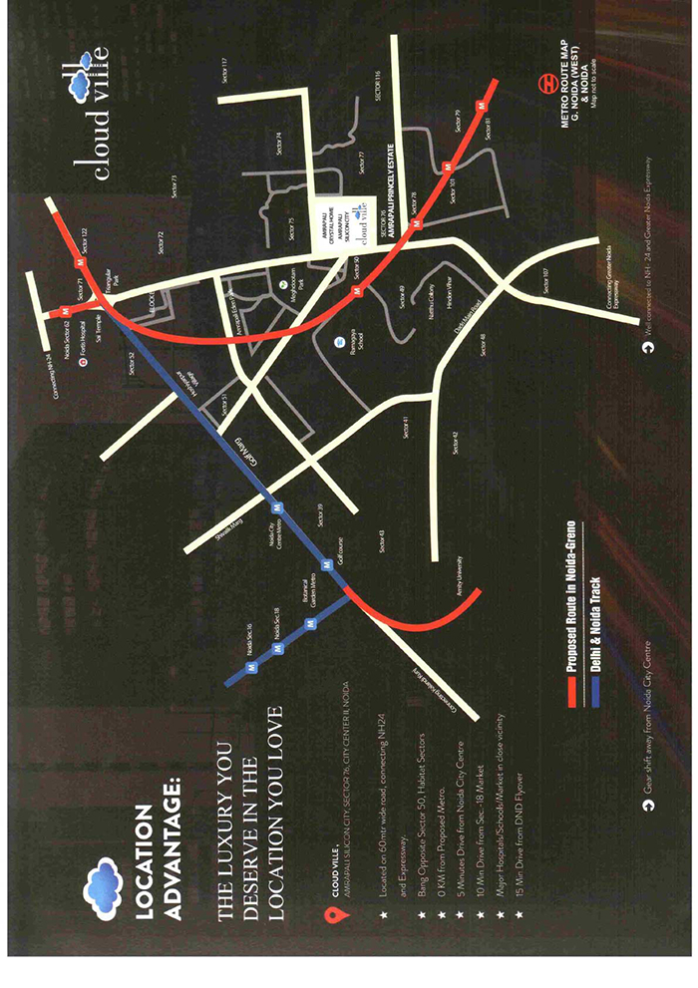](http://www.amrapaligroups.co.in/images/amrapali-cloudville-locatio.jpg)